**Carrier List:** The Carrier List tab holds the list of eligible carriers that CNH dealers can use to have their orders delivered.

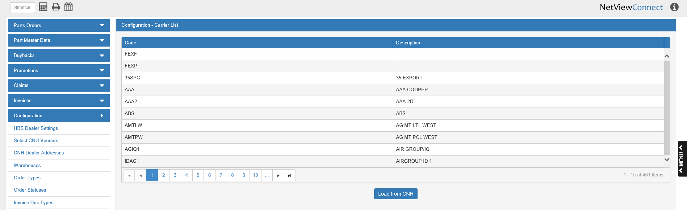

**Code:** This column holds the CNH code for the carrier.

**Description:** This column holds the actual carrier company name.

**Load from CNH:** When you first open CNH Connect (CSPS), you will need to load this list from CNH, or you will not be able to use them in making your orders. After you first click the button, the list will automatically reload every 30 days, but you may click the button at any point to load the most updated version of the list.